TigerOne Mobile Credential for Android

How to provision:

- Visit the Google Play Store and search for GET. Install the app on your device.

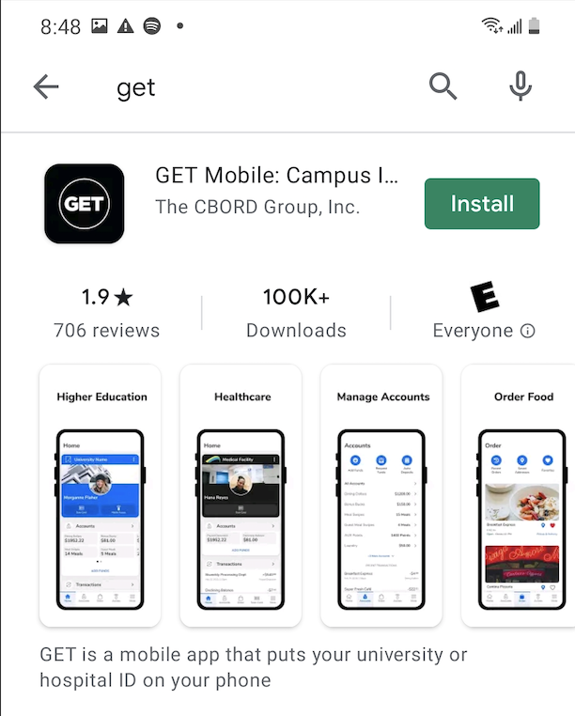

- After installation is complete, go to the Settings app on your device. Search for GET Mobile. Select Permissions, then select Location. Select Allow location while using app. You can set this permission back to Deny after provisioning (step 10).

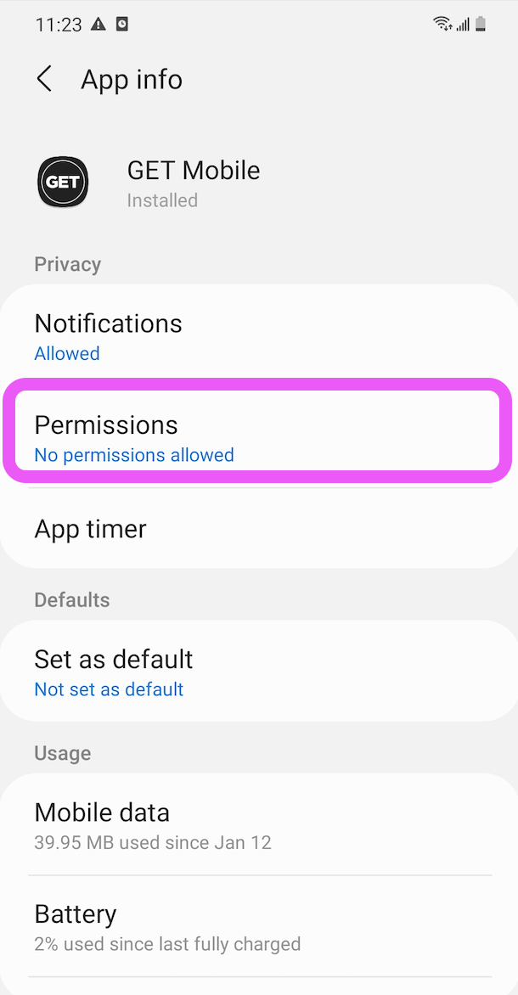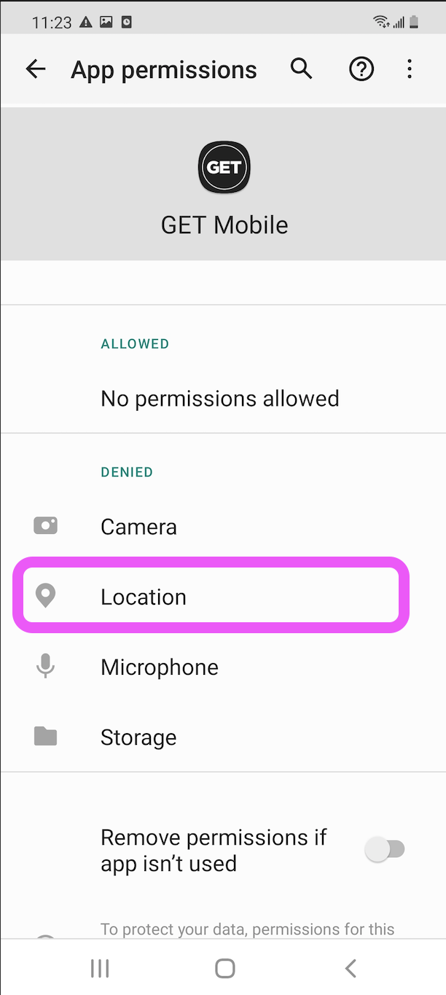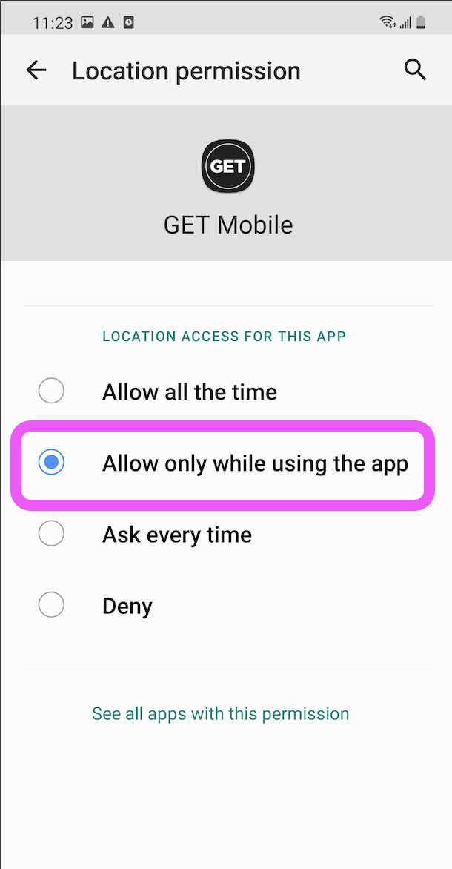

- Open the Get app and select Search All Institutions.

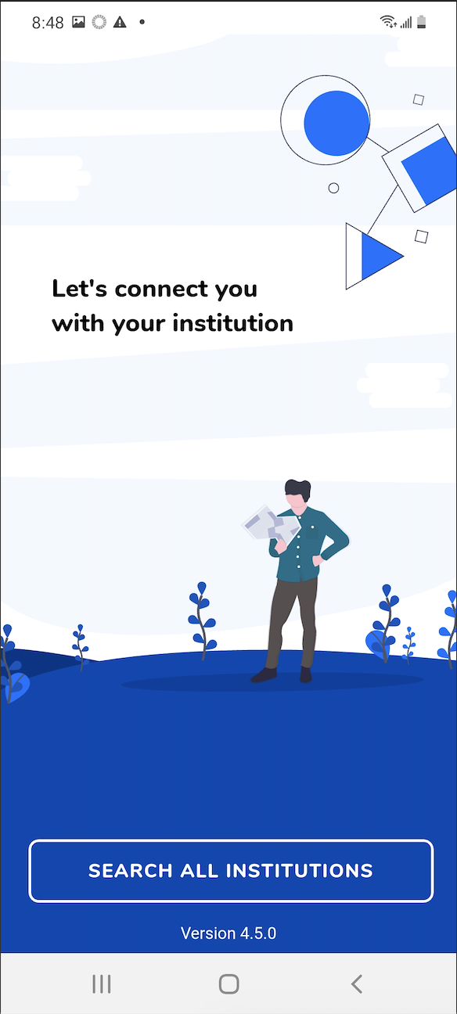

- In the search bar, search for Clemson University. Select Clemson University (not the xxx account).

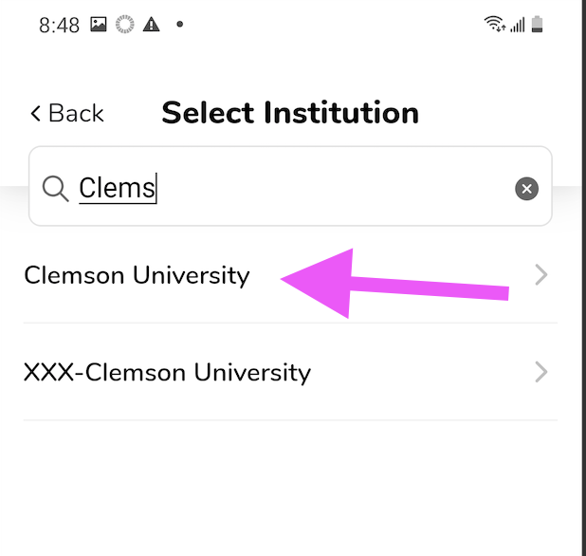

- Login to the Clemson authentication page with your Clemson credentials and then approve the DUO dual authentication notification.

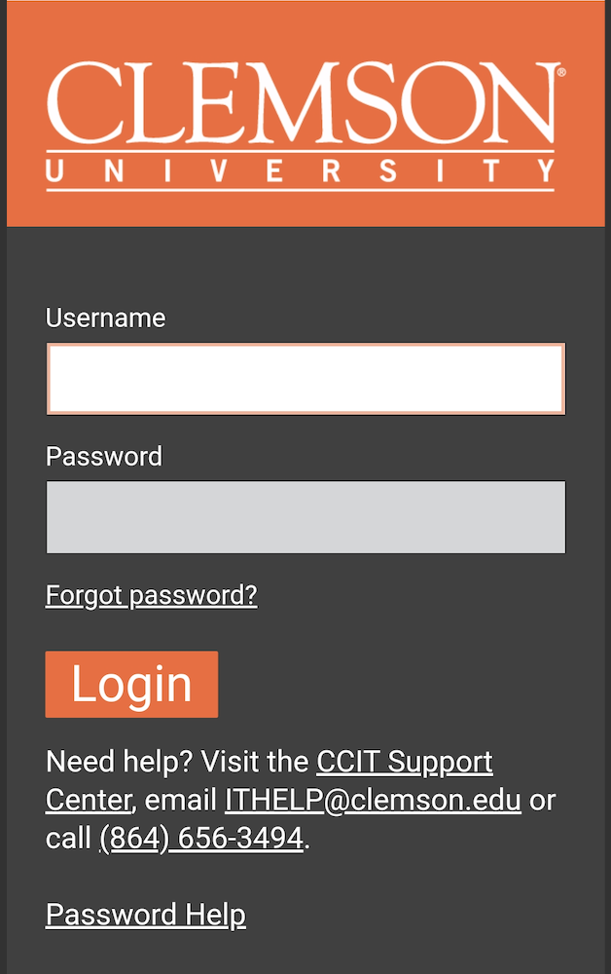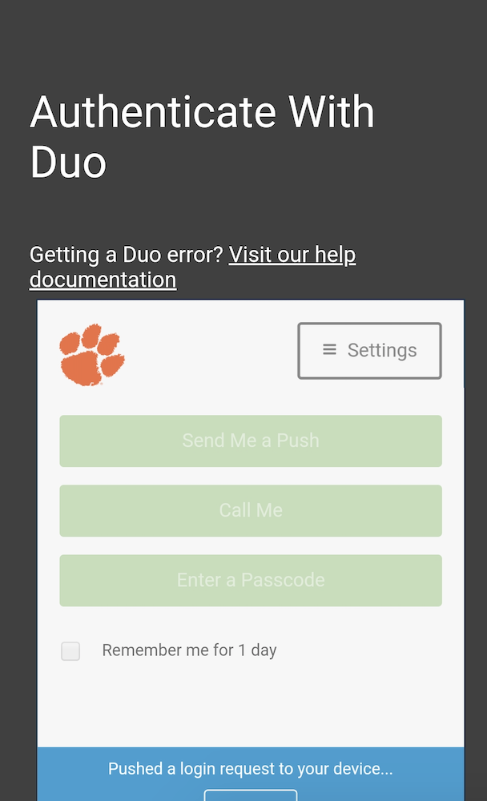

- You will be prompted to create a four digit pin for login into the Get app. You will use this pin as your login to the app from this point on. Use a pin that you will easily remember.

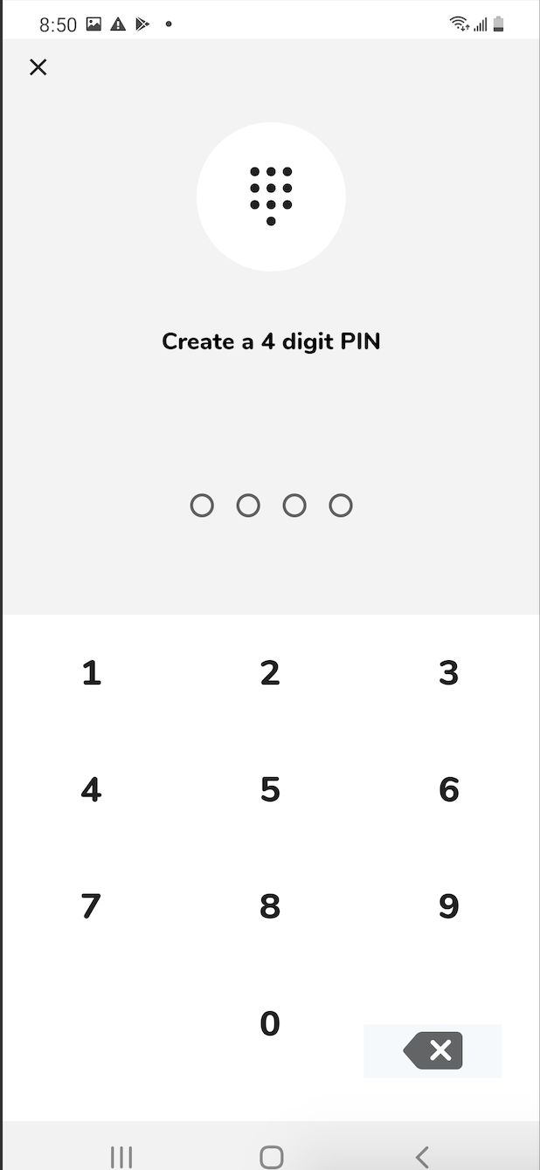

- At the top menu, select Add ID to Phone.

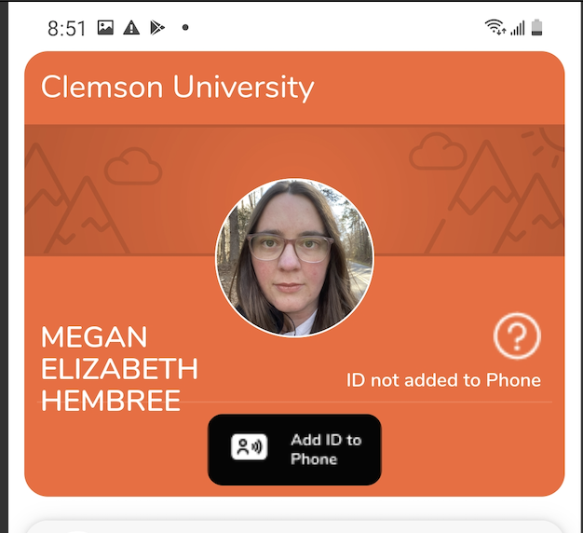

- Agree to the Terms and Conditions of use
- Your Credential is now added to your phone. If you see [not ready] next to your mobile ID status, go back to step 2 and ensure location settings are configured.

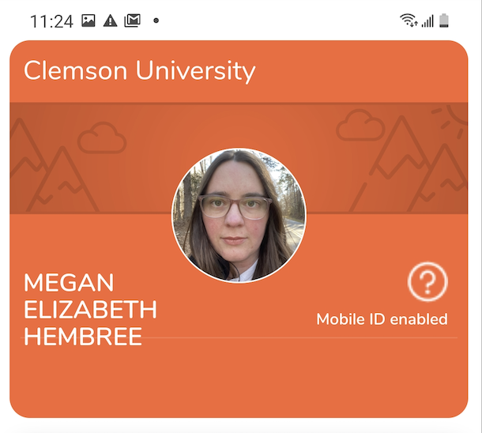

- After the Mobile Credential has been added, you can return to settings and set location permissions to Deny.
- Ensure your device has NFC enabled. The ID communicates to readers via NFC.
- Do not delete the GET app. If you delete the GET app, your credential will be removed from your device and no longer usable.

