
Faculty and Candidate Resource Guide

Contents
Introduction 2
Working at Clemson University 2
Benefits 5
Resources for Faculty 7
Explore Clemson University 9
Bowman Field 9
Carillon Garden 10
The Centennial Oak 10
Clemson Conference Center and Inn and Walker Golf Course 10
Clemson Memorial Stadium 10
Fort Hill 10
Littlejohn Tiger 11
Military Heritage Plaza 11
Memorial Park and Scroll of Honor 11
Outdoor Theater 11
President’s Park 11
South Carolina Botanical Garden and Bob Campbell Geology Museum 12
Strom Thurmond Institute of Government and Public Affairs 12
T. Ed Garrison Livestock Arena 12
The ’55 Exchange 13
Campus Recreation 13
ADDITIONAL RESOURCES AND LINKS 13
Explore The Clemson Community and Surrounds 14
Abernathy Waterfront Park 14
Clemson Experimental Forest 14
Fants Grove (Twin Lakes) Mountain Bike Trails 15
Table Rock State Park 15
Brooks Center for the Performing Arts 16
Clemson Little Theatre 16
Oconee Community Theatre 16
Walhalla Civic Auditorium 16
Clemson Chamber of Commerce 16
Upcountry South Carolina 17
Greenville, South Carolina 18

Introduction
Welcome to the Clemson University Faculty Candidate Resource Guide. As a resource, this document serves to direct faculty and faculty applicants to online information about the University and living in the Clemson area.
Clemson University is a land-grant research university located in upstate South Carolina. The University is home to seven academic colleges and the Calhoun Honors College, with nationally recognized programs, centers, institutes, a distinguished faculty and a location that offers countless resources.

The Clemson University family is one of exceptional talent.

Working at Clemson University
Faculty Policies and Handbooks
- Research Policies:
http://www.clemson.edu/research/policies/
- Policies and Procedures for Tenure and Promotion: https://www.clemson.edu/administration/provost/faculty-resources.html
Work Environment
Clemson University is committed to providing a positive working and learning environment that fosters equitable treatment. As part of building a collegial environment, the University recognizes the importance of initiatives, laws and policies that support inclusive excellence, including the following:
- American with Disabilities and Accommodations:
https://www.clemson.edu/campus-life/campus-services/access/american-disabilities/
- Equal Pay Provisions:
http://workgroups.clemson.edu/FIN5337_HR_POLY_PROC_MANUAL/view_document.php?id=149
- Lactation Support Policy:
https://media.clemson.edu/humanres/policies_procedures/lactation_support.pdf
- Telecommuting Policy:
http://workgroups.clemson.edu/FIN5337_HR_POLY_PROC_MANUAL/view_document.php?id=10
- Family Support and Accommodation Plan:
http://media.clemson.edu/humanres/policies_procedures/Faculty_FSAP.pdf
Faculty Governance
The Faculty Senate serves as the official representative body of the faculty and the link between the University’s faculty and administration. The Faculty Senate reviews and recommends policies and procedures that constitute the Faculty Manual. For more than fifty years, the Faculty Senate has participated in a variety of initiatives to improve the status of the faculty of Clemson University.

- Faculty Senate website:
(http://www.clemson.edu/faculty-staff/faculty-senate/)
- Faculty Manual:
http://www.clemson.edu/faculty-staff/faculty-senate/manual.html
Facts About Clemson University
- History of Clemson:
https://www.clemson.edu/about/history/index.html
- Mini fact book:
http://www.clemson.edu/oirweb1/FB/factbook/minifactbook.cgi
- Did you know?
https://www.clemson.edu/about/did-you-know.html
- About Clemson University:
http://www.clemson.edu/about/
- College Quick Facts:
http://www.clemson.edu/oirweb1/fb/OIRWebpage/
Diversity and Inclusion
- Diversity and Inclusion webpage:
http://www.clemson.edu/inclusion/index.html
- Gender Alliance:
http://www.clemson.edu/centers-institutes/gantt/lgbtq-programs/
- Sexuality and Gender Alliance:
http://www.clemson.edu/centers-institutes/gantt/lgbtq-programs/cu-saga.html
Provost Page
- Clemson University Provost homepage:
http://www.clemson.edu/administration/provost/

International Faculty
- International Services:
http://www.clemson.edu/campus-life/campus-services/international/index.html
- Forms and Documents:
http://www.clemson.edu/campus-life/campus-services/international/forms.html
- Information for international faculty:
http://www.clemson.edu/campus-life/campus-services/international/faculty-staff.html
Dual Career
- Dual Career Faculty Hiring Procedures at Clemson University: http://www.clemson.edu/administration/provost/faculty-resources.html
- HERC (Higher Education Recruitment Consortium) of the Carolinas:
  - Search HERC's database of all academic and staff positions at member institutions in geographical region—for both partners at the same time:
https://main.hercjobs.org/jobs/dualsearch
  - Resource page for dual-career couples :
https://www.hercjobs.org/career_advice/Dual-Careers/dual_career_resources/index.html
  - Jobseeker tools including tips, resources, discounts and relocation support:
https://www.hercjobs.org/career_advice/index.html

Additional Policies maintained by Colleges and Departments

- College of Agriculture, Forestry and Life Sciences: http://www.clemson.edu/cafls/
- College of Architecture, Arts and Humanities:
http://www.clemson.edu/caah/
- College of Behavioral, Social and Health Sciences:
http://www.clemson.edu/cbshs/
- College of Business:
http://www.clemson.edu/business/
- College of Education:
http://www.clemson.edu/education/
- College of Engineering, Computing and Applied Sciences:
http://www.clemson.edu/cecas/
- College of Science:
http://www.clemson.edu/science/

Benefits
Benefit Programs Booklet
- Clemson University, Office of Human Resources provides a Benefit Program Booklet, which provides an overview of the provided insurance and retirement benefits:
http://media.clemson.edu/humanres/benefit_programs_booklet.pdf
*Important retirement Plan Information! Your retirement selection must be made within 30 days of the start of employment.

Faculty Leave Benefits
- Leave benefits are a valuable asset to University employees, providing financial compensation and/or accommodating family, professional and personal needs. Clemson University provides paid and unpaid leave benefits to eligible employees. While the following document does not include all methods for taking paid or unpaid leave, it offers a brief overview of leave benefits provided. Additional information regarding leave benefits can be answered by contacting the Office of Human Resources
- Paid Leave Benefits and Leave Programs Summary:
http://media.clemson.edu/humanres/onboarding/TAW/documents/Summary-Leave-Benefits.pdf
- Note: Sabbatical leave is offered through the college and is not listed in the program summary.
Lactation and Mother’s Rooms
- Clemson University promotes a family-friendly work and study environment for mothers and their infants. As a part of Clemson’s goal to provide employees, student workers and students with work/life balance, the University strives to offer clean, private spaces for new mothers to nurse and/or express breastmilk and flexible opportunities to do so during the work/school day.
- Lactation guidance for mothers:
http://www.clemson.edu/campus-life/lactation-network/index.html

Tuition Assistance Program
- The goal of the Tuition Assistance Program is to encourage professional growth, enhance employee performance and support employee career development.
- The Tuition Assistance Program site:
http://media.clemson.edu/humanres/benefits/Employee_Tuition_Assistance_Program_Details.pdf

Family Support and Accommodation Plan
- The Family Support and Accommodation Plan offers faculty members at Clemson University the flexibility and time needed for balancing their professional and personal responsibilities when they experience a life event that may make it difficult to meet their work obligations.
- The Family Support and Accommodation Plan:
http://media.clemson.edu/humanres/policies_procedures/Faculty_FSAP.pdf
Employee Assistance Program
The Employee Assistance Program (EAP) is a free program available to Clemson University faculty and staff and their dependents/household members and provides a variety of health and wellness, counseling, referral, and consultation services. EAP programs are designed to assist you and your family with work/life issues in order to live happier, healthier, more balanced lives.
- The Employee Assistance Program (EAP):
http://www.clemson.edu/employment/worklife/EAP.html

Sullivan Center
- The Joseph F. Sullivan Center is an interdisciplinary health center at Clemson University. Nurse practitioners and nurses are available Monday through Friday, 8 a.m. to 4:30 p.m. The Sullivan Center offers a range of services, from health promotion and annual physicals with our CU 4 Health program, to lab services, immunizations, and disease management.
- The Joseph F. Sullivan Center:
http://www.clemson.edu/centers-institutes/sullivan/index.html

Resources for Faculty

Clemson is home to some of the nation’s most exceptional professors, and our internationally recognized faculty attract some of the highest-achieving college students. Research opportunities, travel abroad, mentoring programs and campus involvement are all part of the undergraduate experience. The quality of the Clemson teaching experience is also a key part of what shapes Clemson’s students into the innovative and world-changing professionals of tomorrow.
Faculty members and faculty candidates will find the following online links a continuous resource that they will wish to visit often.
Clemson in the Spotlight
- Stories and media releases of faculty and Clemson University in the news receiving state, regional, national, and international attention.
- Clemson in the Spotlight:
http://newsstand.clemson.edu/category/mediarelations/research-mediarelations/
ClemsonForward
- ClemsonForward is the University’s 10-year strategic plan grounded in Clemson’s historic strengths but focused solidly on the future and the challenges facing South Carolina, the nation and the world in the 21st century. The plan aims to ensure that Clemson fulfills its core mission and consistently ranks among the nation’s top-20 public universities and Carnegie tier-one research institutions.
- ClemsonForward:
http://www.clemson.edu/forward/
Faculty Development Programs
- Faculty Leadership Program:
The Provost’s Office, in collaboration with the Center for Corporate Learning in Greenville, conducts Faculty Leadership Development programs. Nominated by the College deans and by the Faculty Senate, faculty members are identified to participate in the program.
- Faculty Leadership Program:
https://www.clemson.edu/administration/provost/leadership.html
- CT2 Faculty Scholars:
Faculty who have served as CT2 Instructors for at least two semesters and who have demonstrated excellence in critical thinking instruction can apply to be designated as CT2 Faculty Scholars at Clemson University. The CT2 Faculty Scholar designation is term-limited, compensated, and contingent upon successful ongoing review. CT2 Faculty Scholars are recruited via a selection process developed by the Clemson Thinks2 Office. CT2 Faculty Scholars are expected to participate in scholarly research initiatives related to critical thinking pedagogy. CT2 Faculty Scholars also participate in the CT2 Institute as instructors or facilitators as well as in ongoing professional development activities through the academic year. Finally, CT2 Faculty Scholars continue to teach CT2 seminars, serve on committees, participate in assessment, and support the Clemson Thinks2 initiative.
- CT2 Faculty Scholars:
http://www.clemson.edu/academics/programs/thinks2/scholars.html

Support Resources Promoting Teaching Effectiveness
The Office of Teaching Effectiveness and Innovation provides leadership in keeping Clemson on the cutting-edge of teaching excellence and innovation, in fostering communication, understanding, and a sense of community between teachers and learners, in helping instructors select the most effective teaching approaches for their student learning outcomes, and in ensuring valid and reliable assessments of teaching and learning.
- Office of teaching Effectiveness and Innovation website: http://www.clemson.edu/otei/
- Available workshops and webinars: http://www.clemson.edu/otei/services.html
- Websites for instructors, websites for instructional use, and publications: http://www.clemson.edu/otei/resource-page.html
Cooper Library
R.M. Cooper Library, Clemson’s main library houses large collaborative study spaces, quiet study areas, a coffee shop and convenience store, group study rooms and the largest computer lab on campus. Library faculty connect the University community with library resources and services needed to support teaching effectiveness, research and learning.
Clemson Libraries provide many services to support research and instruction by university faculty, including: borrowing materials, checking out technology, requesting new items, getting materials delivered to a nearby branch, records management, reserving materials for courses, integrating library concepts into course content, and requesting a proxy card for your graduate student.
- Cooper Library website:
http://libraries.clemson.edu/
- Library Research Services:
http://libraries.clemson.edu/research/

Explore Clemson University
We are happy that you are considering joining the Clemson University family. As you explore Clemson University, there are several points of information that you will want to know.
Clemson University and the surrounding area offer plenty of opportunities to explore both indoor and outdoor activities. If you are looking for outdoor entertainment, our beautiful campus borders the more than 900-mile shoreline of Hartwell Lake, where swimming, water skiing and sailing are favorite pastimes. The mountains are less than an hour away and provide areas to canoe, kayak, white-water raft, hike, camp, snow ski and fish. Indoor recreation is even closer to home, with the on-campus Fike Recreation Center, which features multiple courts and studio rooms, an indoor track, a climbing wall and much more. Clemson’s downtown provides many dining and shopping possibilities. Here are just a few iconic places on campus to add to your list to explore.

Bowman Field
Stretching out from Tillman Hall, Bowman Field was originally a parade ground for Clemson cadets. Today the field is used for student leisure activities and student organization events.
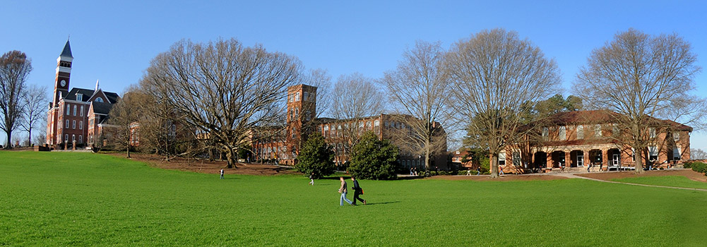

Carillon Garden
Providing a great venue for activities ranging from student meetings to weddings, the Carillon Garden is nestled between Sikes Hall and Tillman Hall and overlooks the Clemson Library. It was given to the University by the Golden Anniversary Class of 1943 and is dedicated as a lasting tribute to the entire class and particularly to those who lost their lives during World War II.

The Centennial Oak
Clemson University is the home of the largest bur oak in South Carolina. The tree is well over 100 years old and was given its name when Clemson celebrated its centennial in 1989.

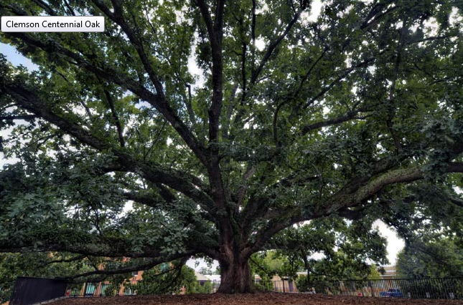

Clemson Conference Center and Inn and Walker Golf Course
The Clemson Conference Center and Inn is a 17,000-square-foot, state-of-the-art facility for symposia, meetings, seminars and other programs. The center includes the Madren Continuing Education and Conference Center, an 18-hole championship golf course and an 89-guest room inn.

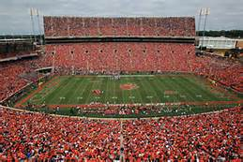
Clemson Memorial Stadium
Better known as Death Valley, Clemson Memorial Stadium is one of the 10 largest on-campus stadiums in America.

Fort Hill
The home of John C. Calhoun and later of his son-in-law, University founder Thomas Green Clemson, Fort Hill is a registered National Historic Landmark located in the center of campus.

Littlejohn Tiger
Outside the Littlejohn Coliseum stands the Littlejohn Tiger, a gift from Tiger Brotherhood. The sides of the statue read: "That the Tiger's Roar May Echo O'er the Mountain Height," the last phrase of Clemson’s alma mater.

Military Heritage Plaza
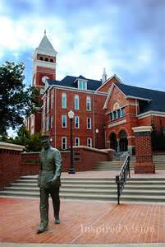
Military Heritage Plaza overlooks Bowman Field and features a life-size statue of a cadet and 41 sets of footprints of former Clemson cadets to commemorate the spirit of Clemson’s military heritage.

Memorial Park and Scroll of Honor
Across from Memorial Stadium, Memorial Park pays tribute to Clemson alumni and friends from a multitude of professions who have served the state and nation. A walkway in the park leads to a reflection point overlooking the Scroll of Honor that lists Clemson alumni who have died in military service.

Outdoor Theater
The Outdoor Theater, also called the bandstand or amphitheater, was a gift from the Class of 1915. The stage is a sunburst of gray, red and beige marble with the year 1915 set in. It is used for activities from pep rallies and outdoor movies to concerts. The Outdoor Theater is located in front of the R.M. Cooper Library’s reflection pond.

President’s Park
Located between the President’s Home and Sikes Hall, President’s Park is one of the most beautiful places on campus. Housed in the park is the President’s Park Rotunda. Created through donations made by the Class of 1957, the rotunda was built to portray Clemson’s historical responsibilities of teaching, research and public service.
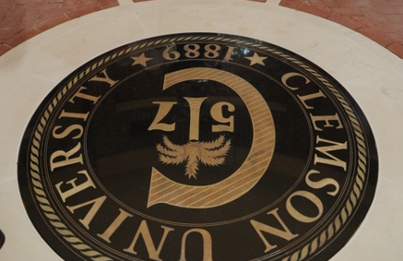

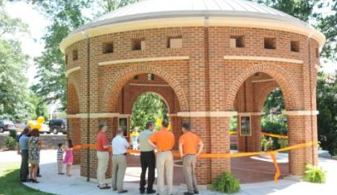

South Carolina Botanical Garden and Bob Campbell Geology Museum
The South Carolina Botanical Garden is a 295-acre public garden just off campus that features several thousand varieties of ornamental plants and a unique collection of nature-based sculptures. On the garden’s grounds you will find the Bob Campbell Geology Museum, which displays a large collection of gems, minerals and other specimens donated by collectors.
- South Carolina Botanical Garden website:
http://www.clemson.edu/public/scbg/
Location - 150 Discovery Lane Clemson, SC 29634
Phone - 864-656-3405
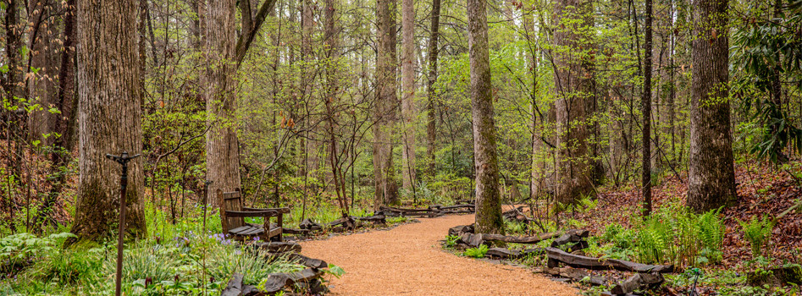

Strom Thurmond Institute of Government and Public Affairs
Strom Thurmond Institute of Government and Public Affairs houses more than 34 tons of papers and memorabilia of South Carolina’s Senator J. Strom Thurmond, the Graem Yates Collection of Presidential Portraits, the institute’s rare book collection, and the University’s archives and manuscript collections.

T. Ed Garrison Livestock Arena
The T. Ed Garrison Livestock Arena is a showplace for livestock activities in the state and hosts horse and livestock shows, rodeos, sales, 4-H activities, educational programs, and industrial and agricultural exhibitions.

The ’55 Exchange
The ’55 Exchange is a student run enterprise that produces, sells and serves Clemson’s world-famous ice cream and other products like blue cheese, eggs, etc. Made possible by a gift from the Class of 1955, all revenues support Clemson students and their academic training Location: Hendrix Student Center

Campus Recreation
Originally built in 1930 as the Clemson Field House, Swann Fitness Center is the main fitness building on Clemson's campus. Across its area of 175,000 sq. ft., the Swann Fitness Center houses state-of-the-art facilities including:
- The McHugh Natatorium
- A 30-foot climbing wall
- A 160-meter indoor track
- Eight racquetball courts
- Six basketball courts
- Two group fitness studios
- A wellness zone
- Approximately 11,000 sq ft. of modern fitness and cardio equipment in the Swann Fitness Center.
- Core Equipment Rentals such as kayaks, paddle boards, canoes, mountain bikes, camping equipment, etc. are available for a minimal fee for Clemson faculty.
- Swann Fitness Center at Fike website:
http://www.clemson.edu/campus-life/campus-recreation/fike/index.html
- Core Equipment Rentals:
http://www.clemson.edu/campus-life/campus-recreation/outdoorrec/index-crp.html

ADDITIONAL RESOURCES AND LINKS
- Explore Clemson website:
http://www.clemson.edu/visit/explore.html
- Clemson University map:
http://www.clemson.edu/campus-map/

Explore The Clemson Community and Surrounds
Nestled in the foothills of the Blue Ridge Mountains, the Clemson area and surrounding Pickens County offers visitors a unique opportunity to explore the great outdoors and connect or reconnect with the Appalachian heritage. There are many things to do — from attractions, arts, events and dining.

Abernathy Waterfront Park
Abernathy Waterfront Park was named after long-time Clemson, S.C. Mayor, Larry Abernathey, and includes a linear waterfront park just over .5 miles long. The park also has picnic areas and lake access.
The Clemson area is surrounded by many beautiful lakes and rivers. Enjoy 87 square miles of open water on Lake Hartwell, escape to the secluded white waters of the Twelve Mile River or paddleboard to a Cliffside waterfall on Lake Jocassee. Clemson is also located close to several waterfalls and lakes.
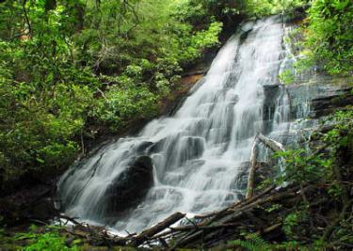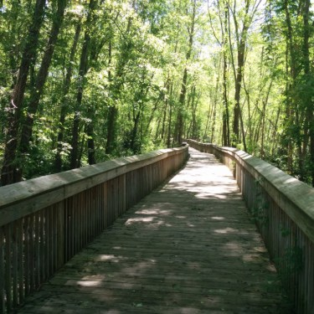

Clemson Experimental Forest
Clemson’s Experimental Forest, Issaqueena Forest, is a large area of protected land surrounding the City of Clemson and Clemson University to the north and south. The forest offers an abundance of multi-use trails popular for hiking, mountain biking and horseback riding. Popular attractions within the forest include Lake Issaqueena and Waldrop Stone Falls.

Fants Grove (Twin Lakes) Mountain Bike Trails
Easy trails in and around the Twin Lakes Recreation area on beautiful Lake Hartwell are a favorite of hikers and trail cyclists.
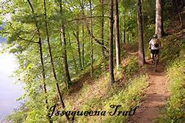

Table Rock State Park
Table Rock Mountain provides a towering backdrop for an upcountry retreat at the edge of the Blue Ridge Mountains. Table Rock State Park features two lakes, a campground, mountain cabins, meeting facilities and its historic, renovated lodge.
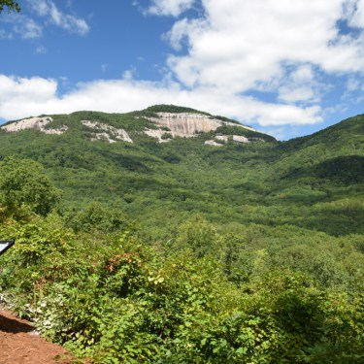

Brooks Center for the Performing Arts
Located on Clemson University Campus, the Brooks Center offers dance, music and theatre talent from across the United States as well as outstanding performances by Clemson students.
- Brooks Center for the Performing Arts
Website: https://www.clemson.edu/centers-institutes/brooks/
Location - Clemson University
221 Brooks Center, Clemson
Phone - 864.656.3043

Clemson Little Theatre
Each year the Clemson Little Theatre produces seven stage plays, drawing on talent from throughout the Upstate area.
- Location: Pendleton Playhouse, 214 S. Mechanic Street; Pendleton
Phone - 864-646-8100

Oconee Community Theatre
A community theatre with a mission to promote interest in the performing arts.
- Location - 8001 Utica St., Seneca
Phone - 864-882-1910

Walhalla Civic Auditorium
Originally a grade school built in 1903 and now listed on the National Register of Historic Places, the restored Walhalla Civic Auditorium brings in first-class entertainment throughout the year. The Walhalla Civic Auditorium’s website provides a complete a calendar of events.
- Walhalla Civic Auditorium website:
http://www.walhallacivic.com/
Location - 101 E. North Broad St., Walhalla, S.C.
Phone - 864-638-5277

Clemson Chamber of Commerce
The Clemson Area Chamber of Commerce fosters and promotes economic growth and vibrant communities through information, service, and advocacy. Whether you are visiting deciding to relocate, the Clemson community has a lot to offer.
- Chamber of Commerce website:
http://www.clemsonareachamber.org/
Location - 1105 Tiger Boulevard Clemson, SC 29631
Email: info@clemsonareachamber.org
Phone: 864-654-1200

- Visit Clemson website:
http://visitclemson.com/
- Accommodations:
http://www.clemsonareachamber.org/accomodations
- Community Calendar:
http://d.clemsonareachamber.org/events/calendar/
- Churches:
http://www.clemsonareachamber.org/churches
- Healthcare:
http://www.clemsonareachamber.org/healthcare
- Relocation Information:
http://www.clemsonareachamber.org/relocation-information
- School Districts:
http://www.clemsonareachamber.org/school-districts
- Weather and Seasons:
http://www.clemsonareachamber.org/weather--seasons

Upcountry South Carolina

The Upcountry of South Carolina abounds with natural resources and recreational opportunities. There are many lakes and rivers to choose from for boating, rafting and fishing. There are state parks, national monuments, heritage preserves and designated wilderness areas that accommodate hiking, camping and horseback riding. With more than 30 waterfalls and close to 40 golf courses in the area, you will be sure to find an outdoor activity that will challenge and inspire you.
It is not just the outdoors that will inspire you in the Upcountry. There are museums and art galleries all over the six county area holding world-class collections and collectables. You will find performance halls hosting Broadway shows, mega-concerts and locally produced talent. Discover the history of the region and our country at preserved historic sites and museums.
- See more than 1,000 things you can explore in the Upcountry of South Carolina at:
http://www.upcountrysc.com/

Greenville, South Carolina
Greenville, South Carolina, located just 30-40 minutes from Clemson is an award-winning city with a vibrant Main Street.
- http://www.visitgreenvillesc.com/plan-your-trip/newsletter-sign-up/
- http://greenvillechamber.org/

