Kronos End of Pay Period Tips & Tricks

**Supervisor Procedures for Pay Period End:**

**\*All managers/supervisors must approve their employee’s timecards, even if all employees are exempt!**

1. Manage Time Off Requests
   1. Make sure all leave requests through 11/15/13 have been approved
   2. Verify that leave time/totals looks correct (too many hours of leave will show if submitted incorrectly)

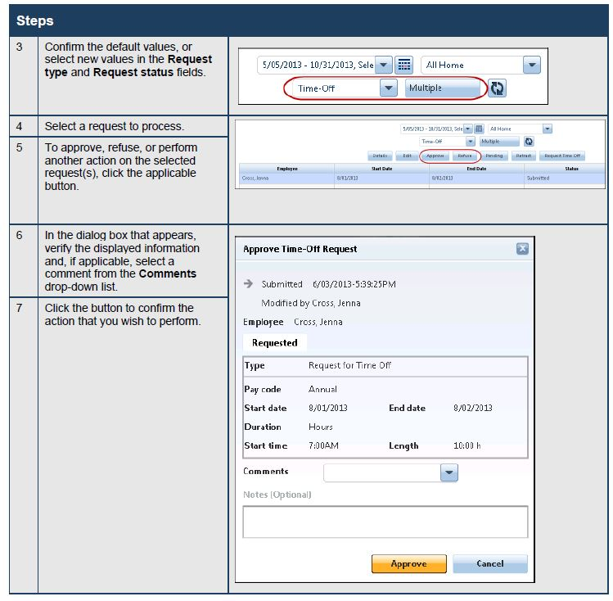

1. Pay Period Totals
   1. Does the employee's time worked equal the appropriate total (i.e. 37.5 hours per week, etc.)?
   2. Make sure there is no unapproved overtime.
2. Pay Period Overview
   1. Check for missing punches

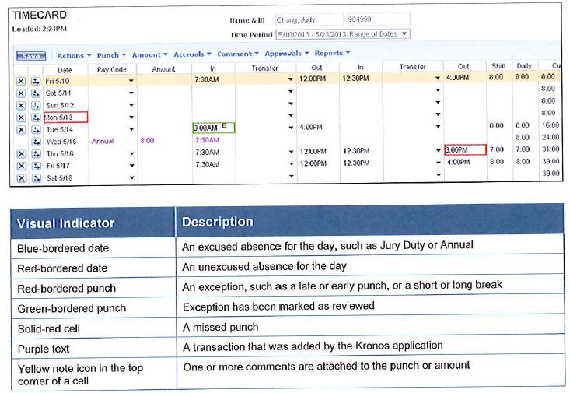

1. Finalizing Timecards
   1. Make sure all employees (those who use Kronos) have timecards approved.
   2. Using the Timecard Approval widget, you can go through the steps of approving a timecard (see pgs. 28-30 in manual)

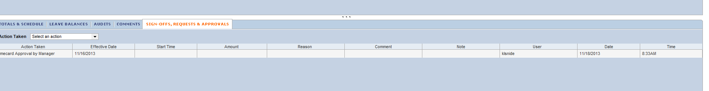

*Approved timecard*