From your Related Items Pane – open the “Reports” widget. Default tab is SELECT REPORT – Open ALL – Choose your report. When you click on a report – a definition of what the reports gives you is displayed.
Choose the group of employees in which you want the report to gather the information on, by clicking on the drop down box. Choose the time period by clicking on the drop down box. Follow other prompts using the drop down box to choose your parameters.

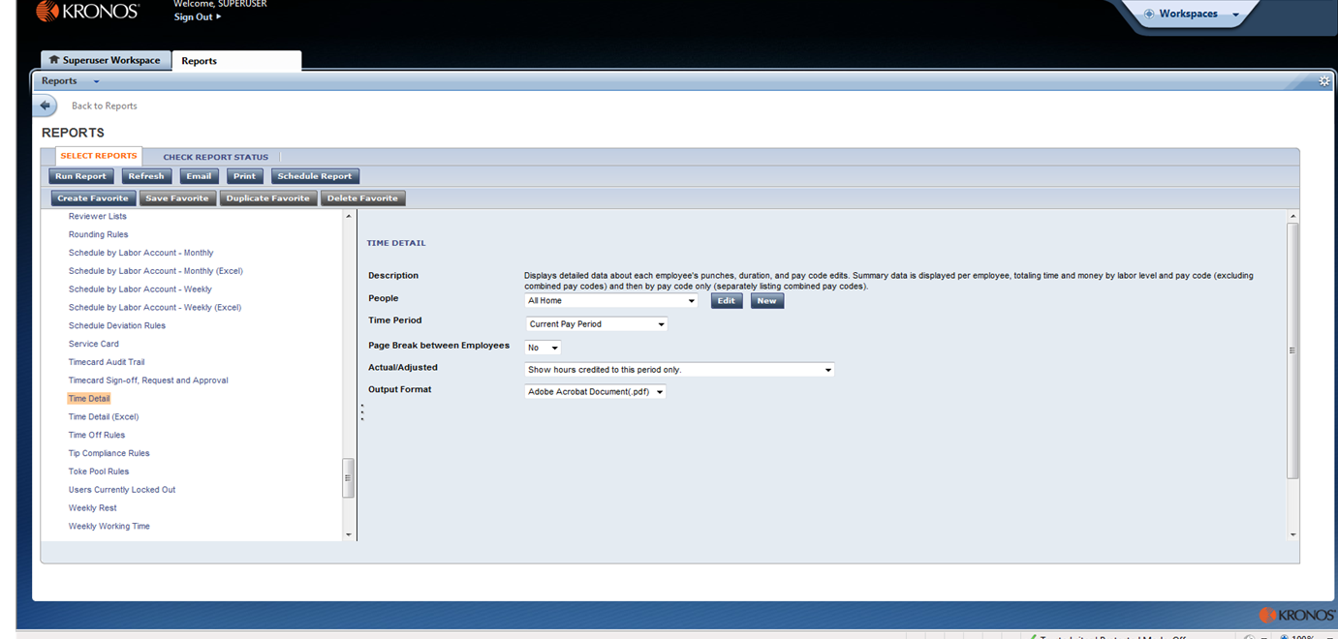
Once you have set all your parameters on the report you have selected - Click the RUN REPORT button on the top left hand corner of the screen.
The report will run – this process takes a few seconds.

The Report Status Report will show on your screen. Hit the “Refresh” button until your Report has a status of COMPLETED. Once the report is completed – highlight the report and Click on the ‘VIEW REPORT’ button in the top left hand corner of the screen. This will open your report in PDF format for you to view or save file.

