To build a Hyperfind query:
- From Related Items, click on Create Query (you may need to scroll down)
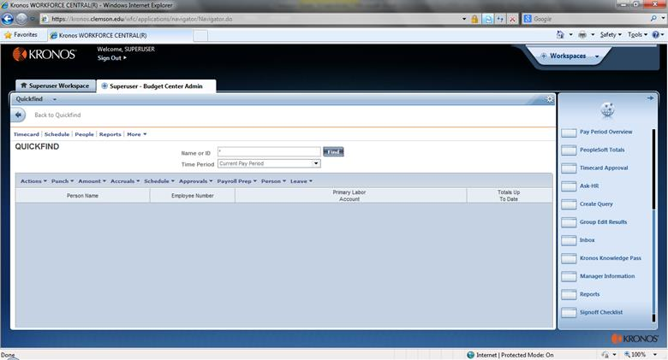
- This screen shows a list of existing Public queries (note Public in the Visibility column). You do not have rights to edit Public queries, but you can select them and Duplicate them. Or you can start over with a new query by clicking New.
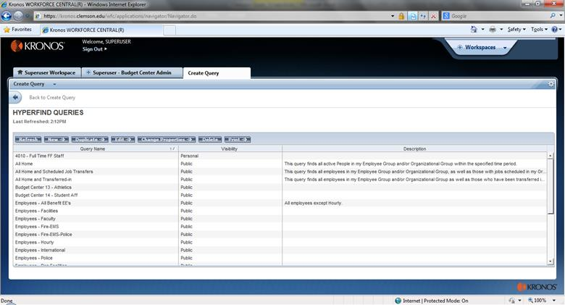
- This is the Hyperfind Query design screen. There are three parts of the screen – the tabs (Select Conditions, Edit Conditions, and View Query), the Filters (left side), and the condition screen (right side). Note: You need to scroll down on the right side to see all of the condition screen.
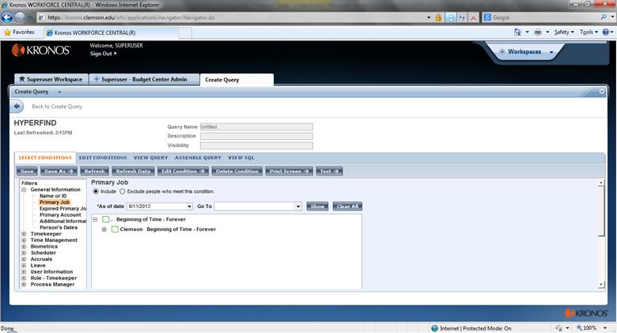
- Note the different types of filters. Popular ones include Primary Account, Additional Information, Employment Status, Pay Rules, Worked Accounts, Worked Pay Codes, and Exceptions.
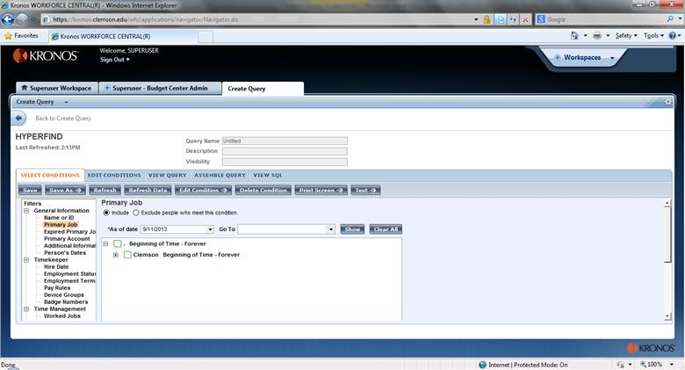
- More filters. Popular ones here include Accrual Item (to check balances or takings), Function Access Profile, and Reports To.
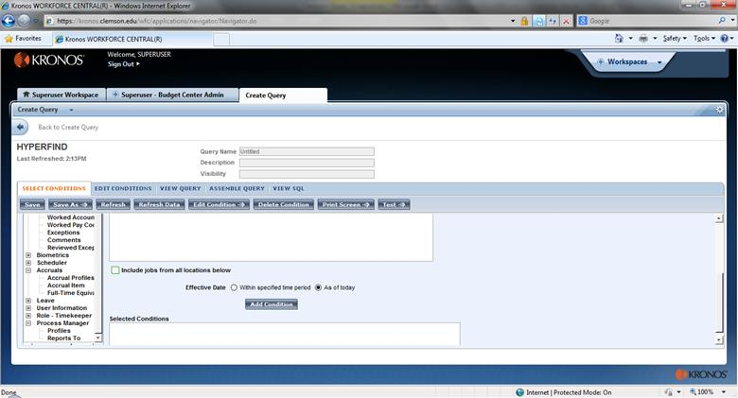
- To build a condition for the query, select the appropriate Filter and then set the filter up as a condition. Each condition allows you to Include or Exclude employees who meet the condition. Here we have a condition to Include anyone whose Primary Account Department is set to 4031. With the department selected, click Add. You may select multiple entries from each labor level. Once the condition is ready, scroll down and click Add Condition to load to Selected Conditions.
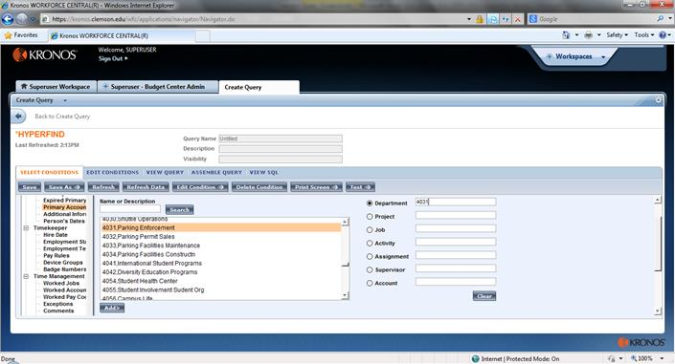
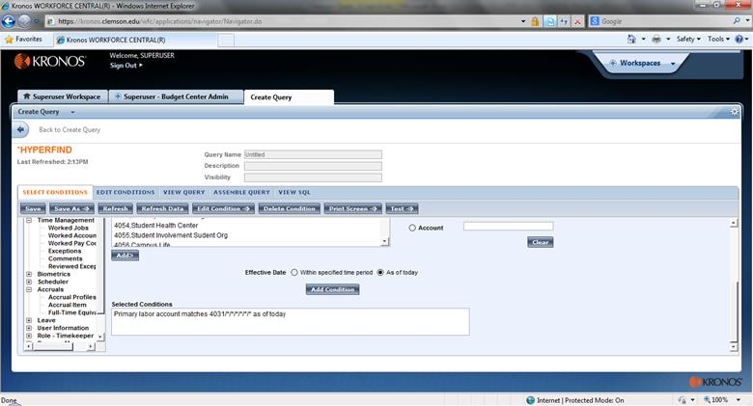
- Recommendation: Use the Employment Status filter to Exclude Terminated employees from all queries (unless building a Terminated Employees query). See here that multiple conditions can be added to the Selected Conditions window.
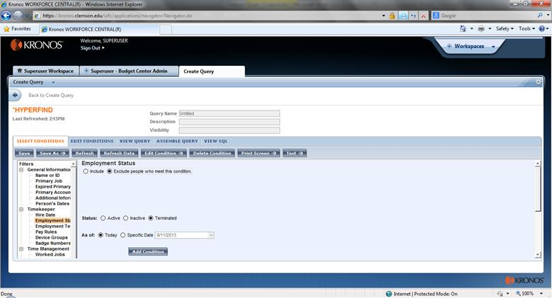
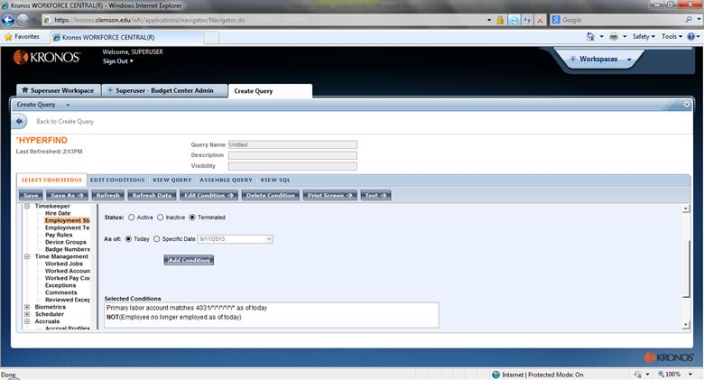
- Select the Edit Conditions tab to see all the conditions loaded. From here, if needed, double-click on a condition to update or change it.
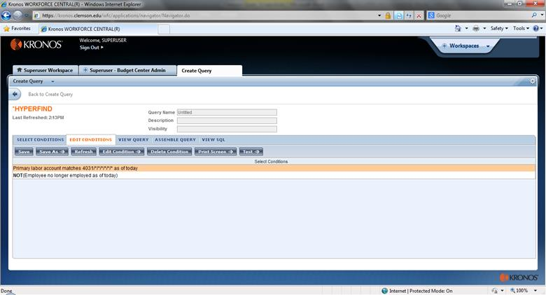

- The View Query tab shows you how the application is grouping the conditions together with “AND” and “OR” connectors.
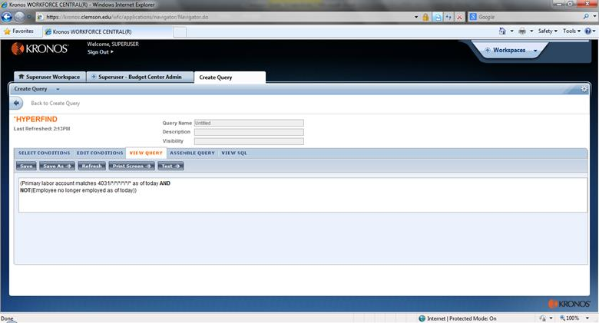
- Once the conditions are ready, click Save As. You have rights to save a query as an Ad Hoc or Personal query. Ad Hoc queries are temporary and will go away after you log out. Personal queries will remain in place, but they will only be visible to you.
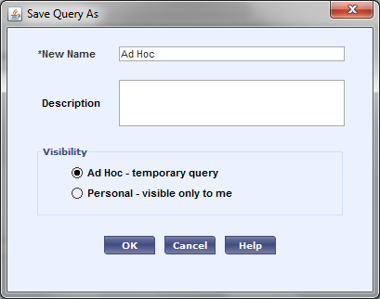

- Name the query, give it a description (optional), and set the Visibility to Personal. Click OK.
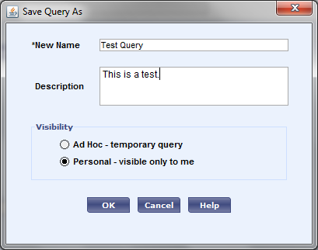

- Queries are used on Genies such as Employee Information. Go to any Genie to use the query by selecting it in the Show window. Be sure to also set your Time Period appropriately.

